Ahsanullah University of Science and Technology

Department of Computer Science & Engineering



**Super Shop Management System**

Database System Concept Lab(CSE 3104)

Submitted To:

Md. Ahasanuzzaman Faisal Muhammad Shah

Lecturer Assistant Professor

CSE, AUST CSE, AUST

Submitted by:

Oishee Bintey Hoque Maisha Binte Rashid

15-01-04-005 15-01-04-009

**Project Title:**

Super Shop Management System

**Project Abstract:**

The main purpose of this project is to manage the whole system of the super shop. The entire system is managed from database. There is all the information about employee, products and branch in the database. Also there is a record of daily transaction of every branch. We can find information if there is any sale on any product.

**Description on Project Working:**

In the database there is information about the stuffs like their name, salary, branch they belong to etc. Here we can find address of every branch which is sorted by district. We keep detailed information of products. We can find their price, quantity, which branch they are available through this application.

We are able to keep the record of daily transaction as there is a payment_id for every transaction. We can also keep track of transaction of every customer using customer_id. In the system we are able to know if there’s sale on any product and if so we can find the sale information.

**Software Requirement:**

* Java Language
* Netbeans IDE 7.0.1
* MySQL server 2005

**Query:**

1. Find the total transaction of every month of year 2017.
2. Find the name and number of products got sold on month 7 in ascending order.
3. Find the name and quantity of products which got sold on Malibagh, Dhaka branch.
4. Find the information of employee who works on Malibagh, Dhaka branch.

ANS:

SELECT Employee_name,Age,Phone_no,Catagory,Gender,Salary FROM employee INNER JOIN branch ON employee.branch_id=branch.branch_id

WHERE branch.district='DHAKA' AND branch.address='Malibagh';

1. Find the sale information, product name and category whose sale_percentage is >=10.

ANS:

SELECT category,name,Validity,Sale_percentage

FROM onsale INNER JOIN product ON product.p_id=onsale.Product_id

WHERE Sale_percentage>=10;

1. Find out the total number of product and their names sold on Dhaka Branch in 2017.

ANS:

SELECT product.name,count(got.p_id) as Total FROM product INNER JOIN got ON got.p_id=product.p_id INNER JOIN payment ON payment.pay_no=got.pay_no WHERE payment.year=2017 AND payment.branch='bo1' Group BY got.p_id ORDER BY Total DESC;

1. Find out which branch has got the highest sale on March,17.

ANS:

SELECT branch.district,branch.address,sum(total) as Total,payment.year FROM branch INNER JOIN payment on branch.branch_id=payment.branch_id WHERE payment.year=2017 Group BY payment.branch_id Order BY Total DESC

1. Which type of product has the maximum sale_percentage.
2. Find out the name of top five products which have got the highest sale on july,17.

**Entity Relationship Diagram:**

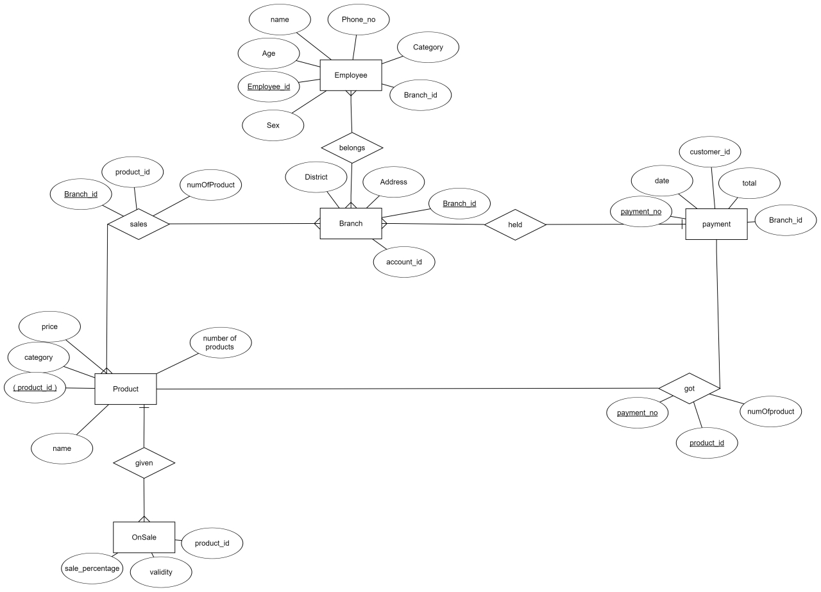

**Limitations:**

* We are unable to handle any error if occurred.
* We are unable to delete any column.

**Future Work:**

* We will try to work on delete operation.
* We will try to add a customer table.